Creating a webhook for automated email notifications when Git settings are changed involves using a service or server to handle the webhook payloads and send email notifications. Here's a simplified overview of how you can achieve this:
- Set Up an Email Service:
You need a service to send email notifications. This could be an email API like SendGrid or a custom email server. Set up the service and obtain the necessary credentials (API key, SMTP server details, etc.).
- Create a Webhook Endpoint:
You'll need a server or service to act as an endpoint for GitHub webhook payloads. This server will receive payloads, analyze them for changes in Git settings, and trigger email notifications. This server can be hosted on your own infrastructure or use a cloud-based service like AWS Lambda.
- Secure Your Endpoint:
If your server is publicly accessible, consider securing it with proper authentication and authorization mechanisms to ensure only GitHub can send data to it.
- Configure the GitHub Webhook:
Go to your GitHub repository.
Click on the "Settings" tab.
In the left sidebar, click on "Webhooks."
Click the "Add webhook" button.
- Configure the webhook:
- Enter the Payload URL, which is the endpoint of your server.
- Select the content type (usually JSON).
- Choose the events you want the webhook to listen to, such as "Repository" or "Repository Contents" events.
- Optionally, add a webhook secret for security.
- Select "Just the push event" if you only want to receive payloads when changes are made to the repository.

- Handle Webhook Payloads:
Your server or service should be set up to receive and parse the incoming GitHub webhook payloads. It should analyze the payload to detect changes in Git settings.
- Trigger Email Notifications:
When changes in Git settings are detected, your server should use the email service you set up in step 1 to send email notifications to the specified recipients. Use the email service's API or SMTP details to send the emails.
Example in Python to receive GitHub webhook payloads.
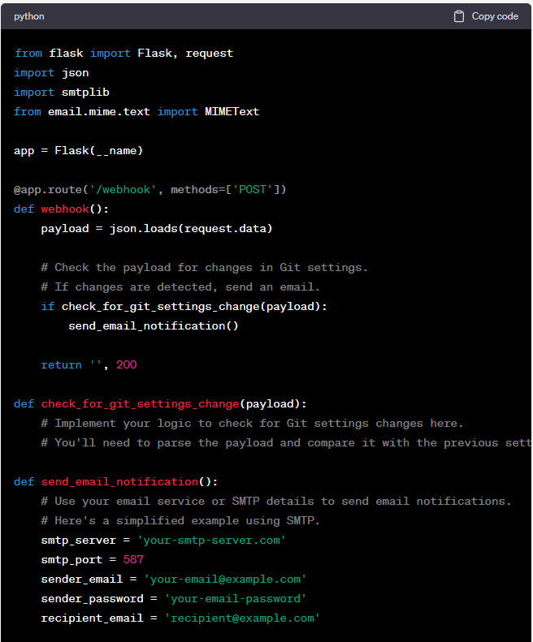
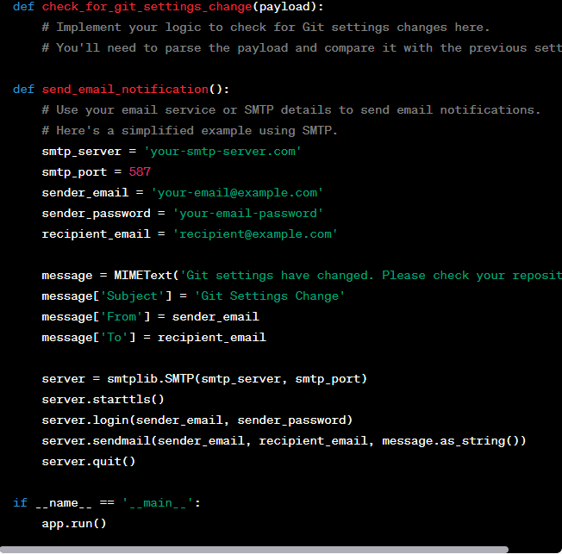
Word code of the above screenshot.

from flask import Flask, request
import json
import smtplib
from email.mime.text import MIMEText

app = Flask(__name)

@app.route('/webhook', methods=['POST'])
def webhook():
payload = json.loads(request.data)

# Check the payload for changes in Git settings.
# If changes are detected, send an email.
if check_for_git_settings_change(payload):
send_email_notification()

return '', 200

def check_for_git_settings_change(payload):
# Implement your logic to check for Git settings changes here.
# You'll need to parse the payload and compare it with the previous settings.

def send_email_notification():
# Use your email service or SMTP details to send email notifications.
# Here's a simplified example using SMTP.
smtp_server = 'your-smtp-server.com'
smtp_port = 587
sender_email = 'your-email@example.com'
sender_password = 'your-email-password'
recipient_email = 'recipient@example.com'

message = MIMEText('Git settings have changed. Please check your repository.')
message['Subject'] = 'Git Settings Change'
message['From'] = sender_email
message['To'] = recipient_email

server = smtplib.SMTP(smtp_server, smtp_port)
server.starttls()
server.login(sender_email, sender_password)
server.sendmail(sender_email, recipient_email, message.as_string())
server.quit()

if __name__ == '__main__':
app.run()

